Biomassters Global, Inc.
SINCE 1996 4894 West Lone Mountain Road Suite 191 Las Vegas, Nevada 89130 USA
Telephone: (+1) 702-645-1390 Fax: (+1) 702-656-2305 Email: info@biomassters.com
Agriculture Website: www.biomassters.com Ethanol Website: http://home.earthlink.net/~test-results2/
Products & Usage
All of our MicroSoil® Agriculture Products are designed to be used for growing any fruit, vegetable or food crops in any/all farming and growing mediums (indoor or outdoor), anywhere in the world, including in hydroponics, greenhouses, aeroponics, gardens, commercial farms, etc.

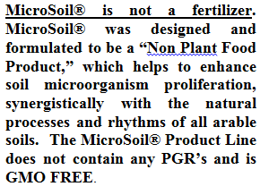
Soils

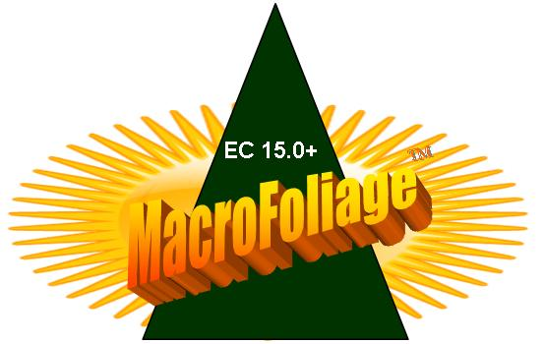
These enzyme/amino acid based products, MacroFoliage®. TripleRich™, EnRich™ N48, and FreshWash™ are designed to be incorporated into water solutions at very low levels for application and use in soils and water, resulting in better crops, cleaner water and an overall healthier environment and eco-systems. Our products contain NO PGRs, are GMO Free and are 100% safe for people, plants & pets

The ultimate foliar
with a plus 15 EC
Apply at 250 to 1,000 parts water to (1) one part product
Foliar Spray

The perfect all purpose
product for soils & foliar

.

Soils & Foliar

The world’s first all
natural/organic product with 48% non- leachable nitrogen

EnRich™ N48 Soils & Foliar

PureFulvic™
Trace Minerals
WHAT ARE FULVIC ACIDS, AND THEIR FUNCTIONS?

FULVIC ACID is the acid radical found in humic matter which is soluble in alkali, acid, methyl ethyl ketone, and methyl acid. Fulvic acids provide multiple and natural chemical reactions in the soil, thereby instigating and stimulating unique and positive influences on plants metabolic processes. Below is a summary list of the unique functions of fulvic acid:
* Assistance in seed germination and growth.
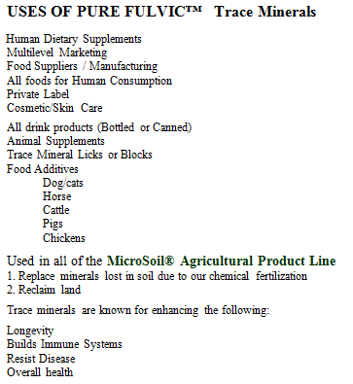
* Improved development of roots and shoots.
* Resistance of plants to fungal attack.
* Metal complexing and nutritional physiology.
* Enhanced uptake of nutrients. Stimulation of plant metabolism.
* Chelation and effects on the plant growth cycle.
* Positive effect on plant RNA and DNA.
* Catalysts in plant respiration.
* Increased metabolism of proteins.
* Increased activity of multiple enzymes.
* Enhanced permeability of cell membranes.
* Enhanced cell division and cell elongation.
* Aid to chlorophyll synthesis.
* Increased drought tolerance.
* Increased growth and yield of crops.
* Assist denitrification by microbes.
* PH buffering capacity.
* Special chemical affinity for balance.
* Participation in syntheses of new minerals.
* Chemical weathering or inorganic substances.
* Silicate decomposition by hydrogen ions of Fulvic acids.
* Aid in the creation of fertile new soil.
* Ability to scavenge heavy metals.
* Detoxification of various pollutants.

BioTech/AgriZymes™

Applications & Uses:
Agriculture-Enhance
Insects- Cleaving Agent
Soil microorganism proliferation
Soil Remediation
Food Processing Plant -Brewery
Food Processing Plant - Dairy
Food Processing Plant - Heavy proteins/Cellulose
Food Processing Plant - Simple Sugars
Meat Processing Plant - Grease
Food Plant - Outside Aeration Pit
Grease Trap Effluent
Fiberglass Manufacturing Plant
Manufacturing - Metals Processing Plant
Manufacturing - Service - (Propylene & Ethylene Glycol)
Hydrocarbon Bio-Remediation
Enhanced Oil Recovery
Recreational Lakes (Bad Algae Blooms, Poor Clarity, Weeds)
Grit Chamber
Lift Station
Sewage Treatment Plant - Aerobic, Grease Trap Effluent
General Purpose Deodorizer, General Purpose Cleaner
Commercial Cleaner
Degreaser
Holding Tanks (Cleaning)
Drains and Drains Lines
Septic Systems
Industrial & Municipal Waste Water Applications, Municipal Grease Control
Municipal Sewer Waste Water
Grease Traps
Lift Stations & Wet Wells
Lagoons & Retention Ponds
Air Scrubbers
Cooling Towers
Compost
Leaching fields
Septic Systems
Septic Dump Site (Odor)
Low Flash Point Cleaning-Rags
Hydrocarbon Remediation
Recreational Lakes, Ponds, Swim Ponds, Swim Ponds, Pool & Spa Water Clarification

